St. Mary Catholic Church of Ashland
St. Joseph Catholic Church of Greenwood

ACH Authorization Agreement for Electronic Donations

In response to God’s provision in my life, I establish this electronic fund transfer agreement
to provide consistent financial support for His work through the ministry of the Church.

(Please Print) Name: ________________________________________________________________________

Address: _______________________________ City: ____________ State: _____ Zip: ______________

Phone: ____________________ Email Address: _______________________________________________

- I wish to make the following ongoing monthly commitment, as a donation to be made to:
St. Mary Catholic Church of Ashland St. Joseph Catholic Church of Greenwood

- Electronic Payment will be made on the 15th of each month.

Total Amount per Month: $ _____________

- Please take my contribution directly from the account specified:
Checking Account (attach voided check) Savings Account (attach deposit slip)

Routing Number: __________________

Account Number: __________________

- I hereby authorize St. Mary Catholic Church or St. Joseph Catholic Church and Centennial Bank or Farmers & Merchants Bank to initiate debit entries into my account. This authorization is to remain in full force and effect until I give written notification of its change or termination, in such time and manner as to afford reasonable opportunity to act on it.

Authorized Signature: ____________________________________ Date: __________________
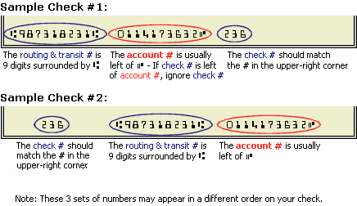
Please attach a Voided Check or Deposit Slip here

